

A USER MANUAL

OF AN AUTONOMOUS SHOPPING CART

By

ALOWOLODU OLUWANIFEMI EBUNOLUWA (CPE/17/3102)

SUPERVISED BY

PROF E.O OGUNTI

SUBMITTED TO

THE DEPARTMENT OF COMPUTER ENGINEERING,

SCHOOL OF ENGINEERING AND ENGINEERING TECHNOLOGY,

FEDERAL UNIVERSITY OF TECHNOLOGY, AKURE, ONDO, NIGERIA.

IN PARTIAL FULFILMENT OF THE REQUIREMENTS FOR THE AWARD

OF BACHELOR OF ENGINEERING (B.Eng.) IN COMPUTER ENGINEERING.

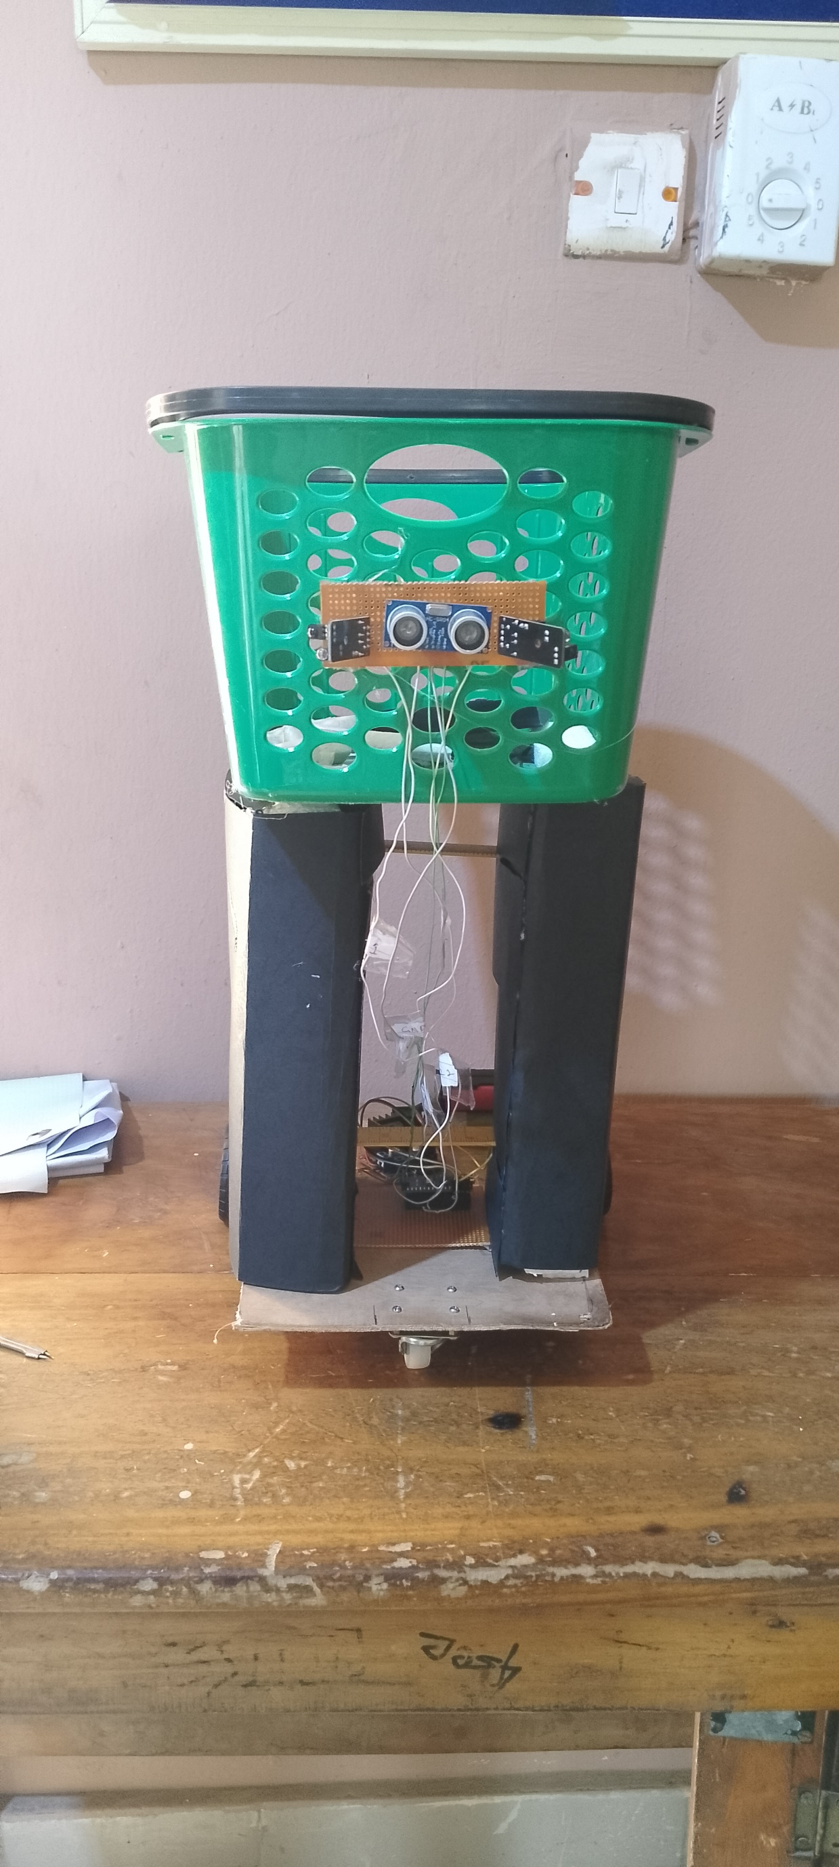

1. Product Features

1.1 Smart Navigation

The autonomous shopping cart utilizes advanced sensors and algorithms for smart navigation, ensuring smooth and obstacle-free movement.

1.2 Human Following

Equipped with infrared sensors, the cart intelligently follows the user, providing a hands-free and convenient shopping experience.

1.3 Obstacle Avoidance

Integrated ultrasonic sensors enable the cart to detect obstacles in its path, automatically adjusting its route to prevent collisions.

2. System Connection

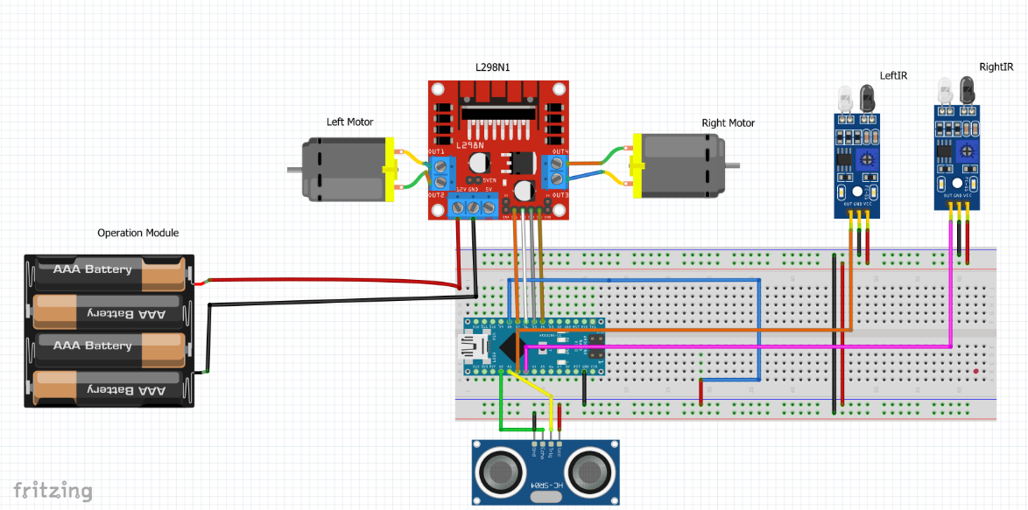

2.1 Powering On

1. Ensure the shopping cart is placed in an open space.
2. Power on the cart using the designated power button (switch).

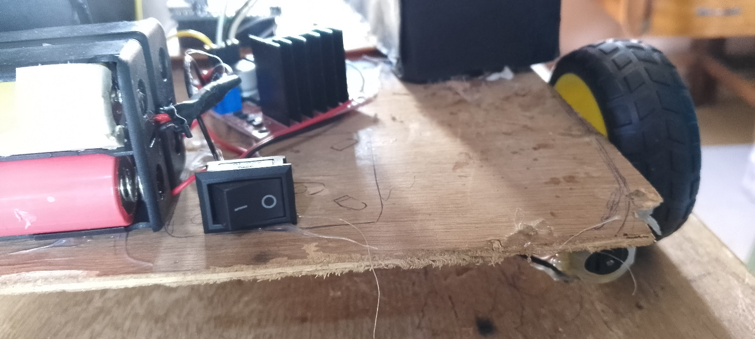

2.2 Charging

a. Connect the provided charger to the designated charging port. The charging module for the cart is separate from the powering module.

b. Ensure the batteries are properly placed to avoid short circuiting

c. Wait for the cart to fully charge before use.

3. Operation

3.1 Smart Navigation

a. The cart will autonomously navigate through the store, avoiding obstacles and following the user.

b. the cart will not start to move unless the user is more than 15cm away from the cart, after which it begins to follow the cart.  
c. if the cart doesn’t sense the user through the ultrasonic sensor, it checks through the left and right IR sensors if the user is present, after which the user follows the user. If not, the crt stops moving.

3.2 Emergency Stop

a. In case of an emergency, press the switch to halt the cart's movement.

4. Technical Specification

4.1 Power

- Operating Voltage: [5-12V]

- Battery Capacity: [8.4V]

4.2 Motors

TT Reducer Motors [DC Gearbox Motor]:

|  |  |
| --- | --- |
| Parameter Operating voltage | 3V-6V DC (Recommended Value is 3V) |
| Load current | 200mA (500mA MAX) (3V pm) |
| Maximum torque | 800g.cm (3V) |
| Continuous No-Load Current | 150mA +/- 10% |
| Power Consumption | 0.24W |

Motor Driver: [L289N]

|  |  |
| --- | --- |
| Operating voltage | 5V-35V DC |
| Operating current | 2A |
| Maximum Power | 25w |

4.3 Sensors

Infrared Sensors: [Specify]

|  |  |
| --- | --- |
| Parameter Operating voltage | 3V-6V DC (Recommended Value is 3V) |
| Load current | 200mA (500mA MAX) (3V pm) |
| Maximum torque | 800g.cm (3V) |
| Continuous No-Load Current | 150mA +/- 10% |
| Power Consumption | 0.2W |

Ultrasonic Sensors: [HCSR04]

|  |  |
| --- | --- |
| Parameter Operating voltage | 5V |
| Operating current | <15mA |
| Operating Frequency | 4MHz |
| Measuring Distance | 2cm to 400cm |
| Power Consumption | 0.75W |

4.4 Microcontroller

Arduino Nano:

|  |  |
| --- | --- |
| Power supply voltage | 5V |
| **Input power supply** | 7-12V (recommended) |
| Number of digital pins | 14, 6 of them can be used as PWM outputs |
| **Analog inputs** | 8 |
| Maximum current of the digital output | 40 mA |

4.5 Dimensions

a. Length x Width x Height: [20cm x 32cm x 50cm]